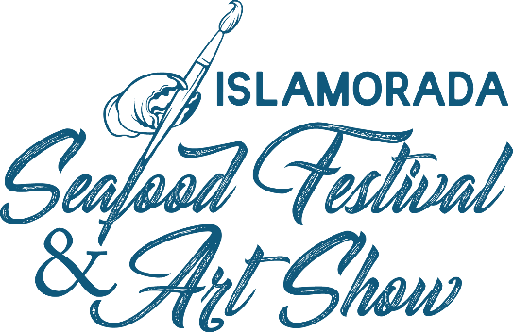
Islamorada Moose Lodge #2151 presents
the 2022 Islamorada Seafood and Art Festival
Sunday, March 20, 2022 • 11am - 5pm

VENDOR REGISTRATION
VENDOR NAME ____________________________________________ FOOD ART
ADDRESS ____________________________________________________________________
PHONE _______________________ EMAIL _______________________________________
WEBSITE:________________________ FACEBOOK PAGE:__________________________
IF FOOD - PRODUCT(S) BEING SERVED w/DESCRIPTIONS AND PRICING. (Max two (2) per booth – at least one food item must be seafood)
1._________________________________________________________________ $ ________
2._________________________________________________________________ $ ________
10 X 10 BOOTH(S) RESERVED - $175 EACH __________
OPTIONAL: ELECTRIC ($25) YES___ NO __ TENT ($100) YES___ NO ___
FOOD TRUCKS (limited availability): size of vehicle____________________________
SPECIAL ACCOMODATIONS: ______________________________________________________
OPTIONAL 10% DONATION OF SALES PROCEEDS YES____ NO ____
AUTHORIZED SIGNATURE: _____________________________________
All profits from this event will go to support local Moose Charities.
NOTE: Please provide to the Islamorada Moose Lodge the product that you are intending to sell no later than March 7th.
In an effort not to duplicate products, the Moose Lodge will approve all products on a first come, first serve basis. In the event of duplication, the later submission will be requested to change product. Thank you for understanding.

EMAIL FOOD & ARTIST BOOTH APPLICATIONS: MooseCall2151@gmail.com Checks payable to Islamorada Moose Lodge 2151 | Mail checks to: PO Box 629, Islamorada, FL 33036

1 of 2

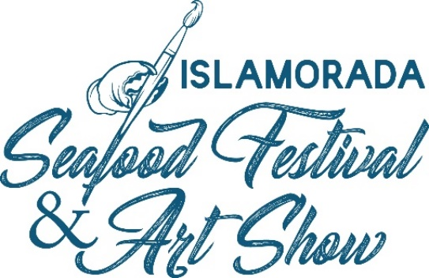
2020 Islamorada Seafood and Art Festival
Sunday March 20, 2022 • 11am - 5pm

FOOD and ART VENDOR INSTRUCTIONS AND PROCEDURES
SET UP
- Booth locations will be determined through a blind drawing conducted by the festival committee
- Food vendors will be alternated with art vendors throughout the festival site
- Booth location will be communicated to each vendor no later than Friday, 3/18.
- Setup will be available to begin at 7:00am Sunday and must be completed by 10:30am
- All vendor vehicles must be removed from the festival site by 10:30am
- All vendors equipment must be broken down and removed from festival site no later than 8pm
- All vendors need to supply decorations and signage displaying the items being sold with pricing
- All vendors are requested to provide a receptacle for their own trash
- All vendors using propane to cook with MUST have a fire extinguisher according to Village Code
- An Islamorada Temporary Food Vendor Requirement Sheet will be provided on-site
PRODUCT SALES
- All food vendors must sell at least one item featuring seafood - this is a SEAFOOD FESTIVAL
- Please have all registration paperwork submitted no later than March 7, 2022.
- 100% of sales retained by the individual vendor
- Please be sure to provide an adequate cash bank for your booth so you can make change
- Please limit all items served to a tasting portion in order to allow the most sampling for all guests and vendors participating
- Please do not serve composed meals (protein/starch/veg)
- Each vendor is limited to serving no more than 2 items per booth
- We suggest pricing to be between $5 and $8 per portion depending on cost/variety of seafood utilized
- All food vendors are restricted to food sales only
- All beverage sales (water, soft drinks and alcoholic beverages) are exclusive to Islamorada Moose Lodge and Florida Keys Brewing Co.
A pre-event festival meeting is scheduled for Monday, March 14th at 6pm at Islamorada Moose Lodge to review all last-minute details. All vendors are invited to attend. We look forward to another great turnout and another very successful annual event.
2 of 2

